Telehandler Inspection Checklist
Serial Number |  | Thorough Examination Expiry Date
Size |  | Week Commencing Date

Ensure you are on suitable ground before conducting functional tests.
If any faults are found note them on this sheet (use the back if required) and inform your Manager / Supervisor immediately.
Do not operate the machine if it has faults!
Hand this sheet to your Manager / Supervisor at the end of each week.

√=OK | X=Fault | NA=Not applicable / Not checked

ON THE MACHINE, OUTSIDE THE CAB
Item | Things to check |  | Mon | Tue | Wed |  | Thu | Fri | Sat | Comments
Mirrors | Clean, damage, properly adjusted
Windows | Clean, damage, front and top
Windshield Wipers | Arm and rubber blade intact
Forks | Damage, cracks, misalignment, check welds, locking pins in place and secure
Warning Decals | Present, legible, damaged
Tyres | Damage, bulges, correct Ply rating?
Wheels | Loose lug bolts, bent rims, cracks
Differentials | Oil leaks, cracks in housing
Guards and covers | Damage, in place
Steps and Handrail | Damage, cleanliness
Stabiliser Arms, Cylinders, Pads | Damage, oil leaks, cylinder rod, missing bolts
Battery/Terminals | Cable connections, water, clean –no corrosion
Overall Machine | Loose/missing nuts / bolts, Loose guards, Damaged, clean
ENGINE COMPARTMENT
Air Filter | Restriction indicator
Radiator Fin | blockage, leaks, cleanliness
All Hoses | Cracks, wear spots, leaks
All Belts | Tightness, wear, cracks, delamination
Overall Engine Compartment | Rubbish or dirt build-up, leaks
INSIDE THE CAB
ROPS or FOPS | Damage, loose bolts
Seat | Adjustment, pedal travel
Seat Belt & Mounting | Damage, wear, adjustment, function
Fire Extinguisher | Charge, damage, inspection card to date
Horn, backup alarm, lights, wipers |  | Proper Function
Controls, gauge lenses |  | Proper Function, cleanliness
Overall Cab |  | Interior Cleanliness
The Driver
Item |  | Things to check | Mon | Tue |  | Wed | Thu | Fri | Sat | Comments
Understands Good Order |  | Are you familiar with the requirements of the Good Order campaign
Understands Good Work |  | Are you familiar with the requirements of the Good Work campaign
Training |  | Do you have a current CPCS card for the item of plant you are operating
Familiarisation |  | Are you familiar with the model of telehandler, its functions and controls, and any attachments you are using
Supervision |  | Do you know who you supervisor is?
Fit and well to carry out work |  | Are you?
Accessories
Item |  | Things to check | Mon | Tue |  | Wed | Thu | Fri | Sat | Comments
Slings, bin handlers, chains etc |  | Suitable storage, free from damage, good condition

Daily Tyre Pressure Checks

 | Mon | Tue | Wed | Thu | Fri | Sat | Comments
Front Left PSI
Front Right PSI
Rear Left PSI
Rear Right PSI

Manufacturer’s Recommended Tyre Pressure
Tyre pressure | Front Left: psi | Front Right: psi | Engine oil level
 | Rear Right: psi | Rear Left: psi | Engine Coolant Level
 |  |  | Hydraulic oil level
Tolerance must be withing + or – 5% manufacturers recommended PSI.

Additional comments
Use diagram below to assist if required
(this may not exactly represent your machine, however it can still be used to illustrate areas of concern)

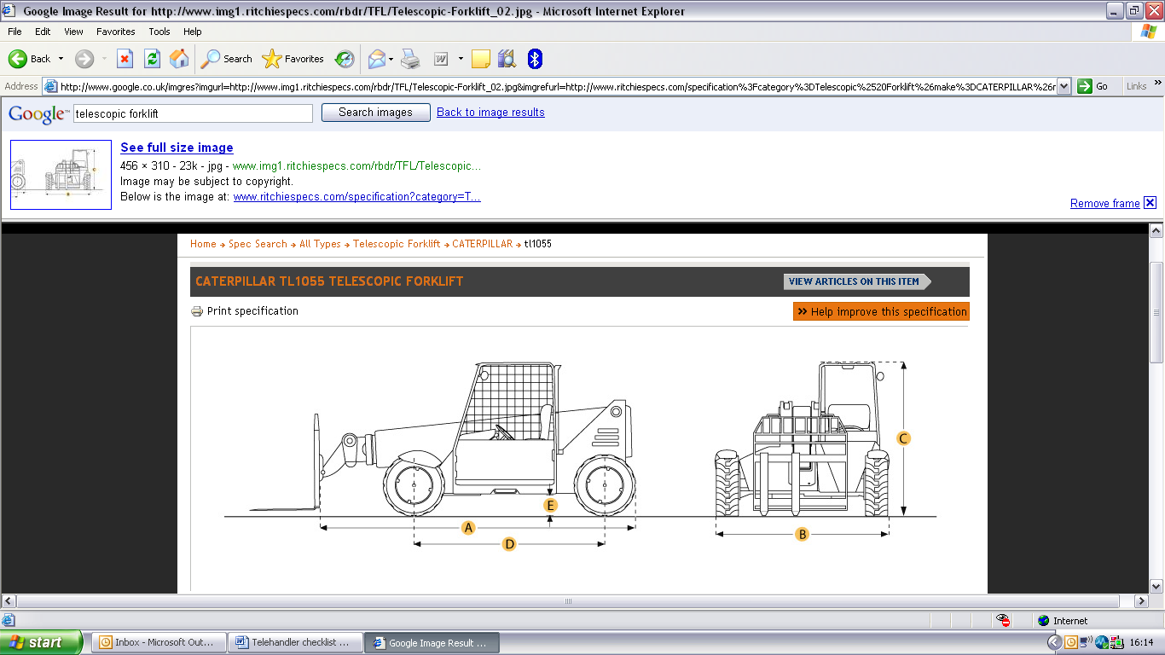

Operator Name |  | Sign |  | Date
Supervisor Name |  | Sign |  | Date

